Work List

Artwork Thumbnail | Title
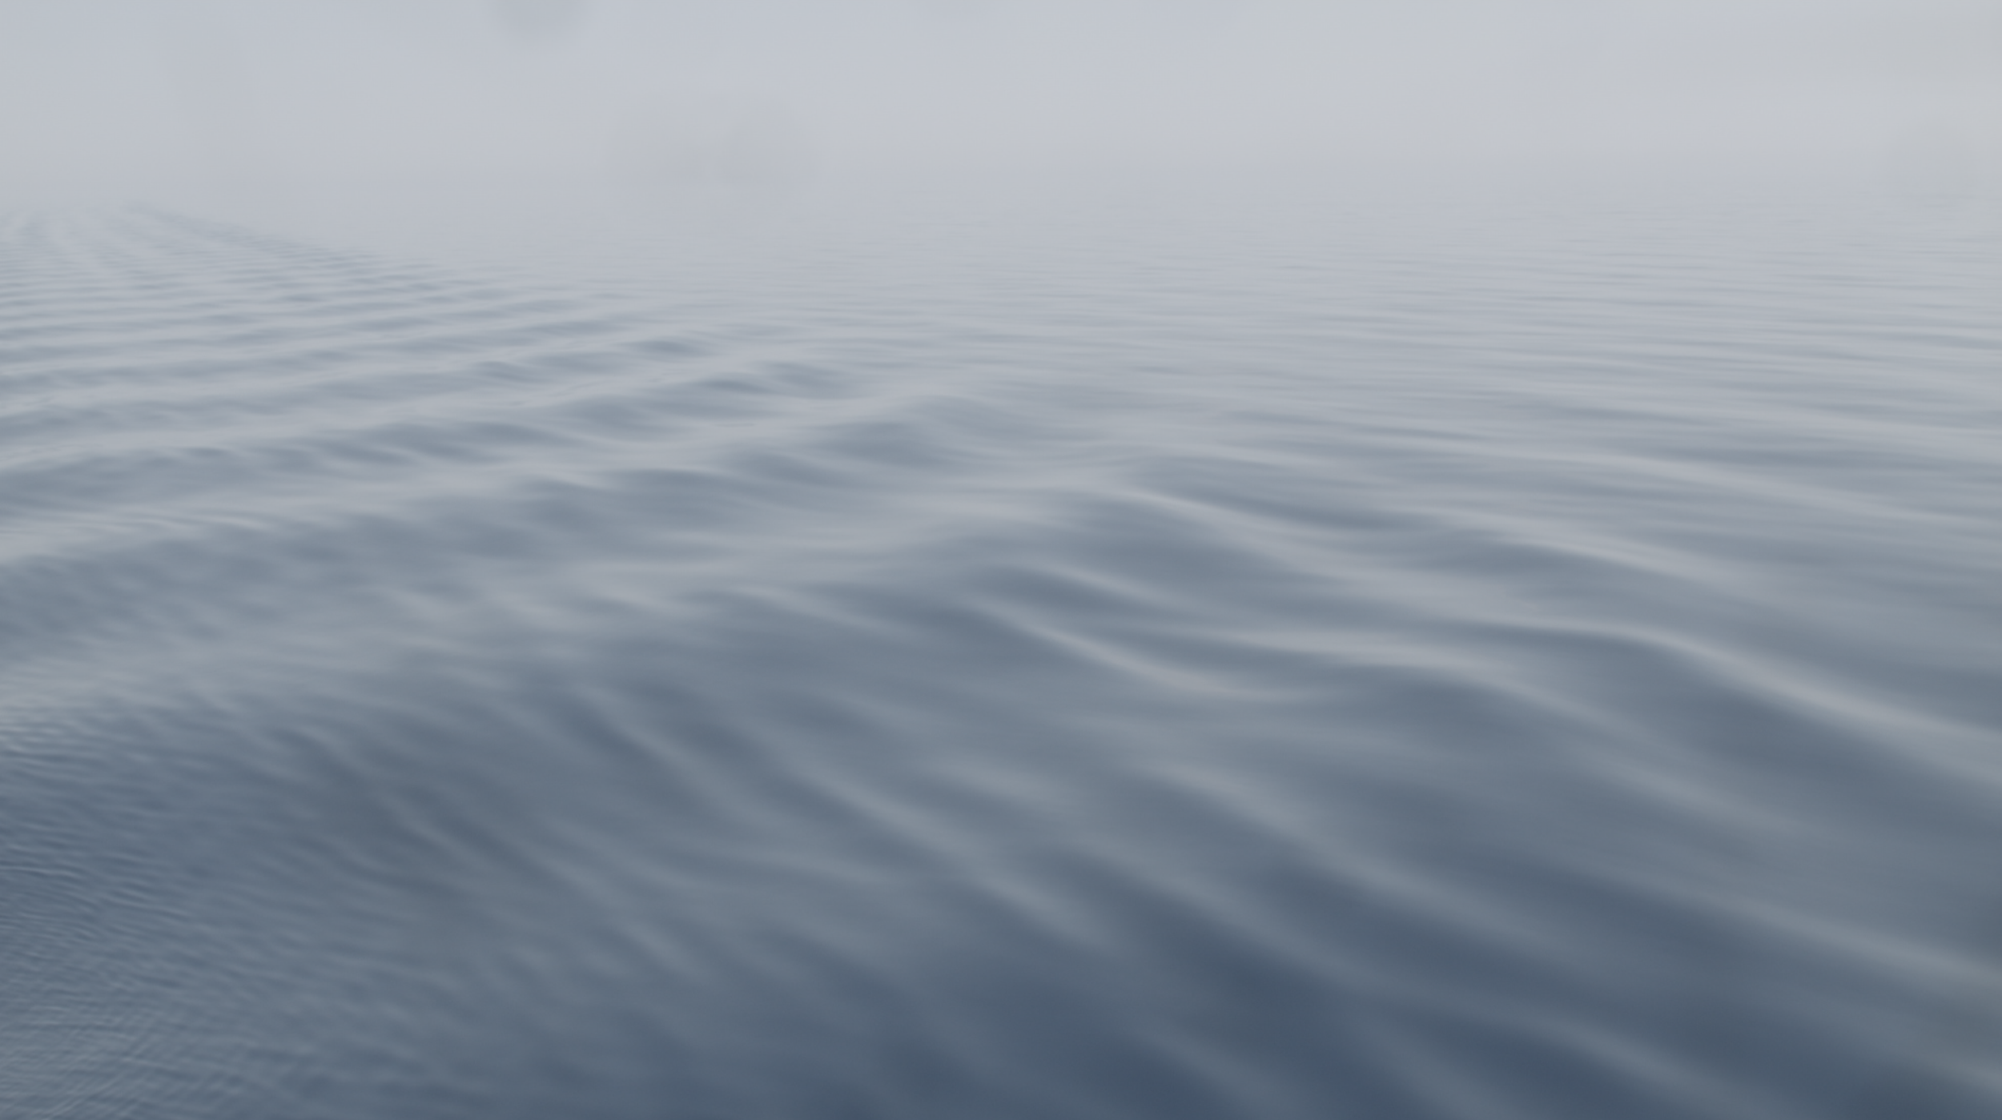 | Mike HJ Chang  Seasick Sketches  2020  Single Channel Video  Video duration: 00.10’.00”
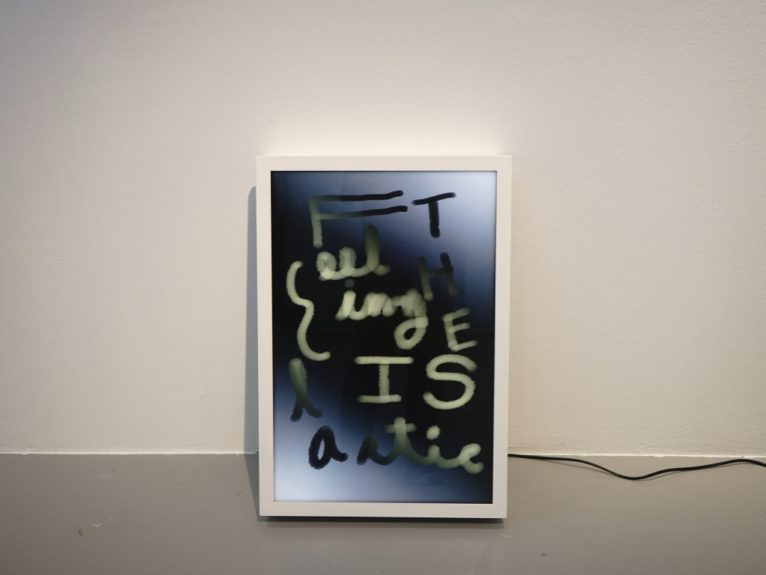 | Mike HJ Chang  The Feeling is Elastic  2020  Metal lightbox, LED light, digital print  64 x 44 cm
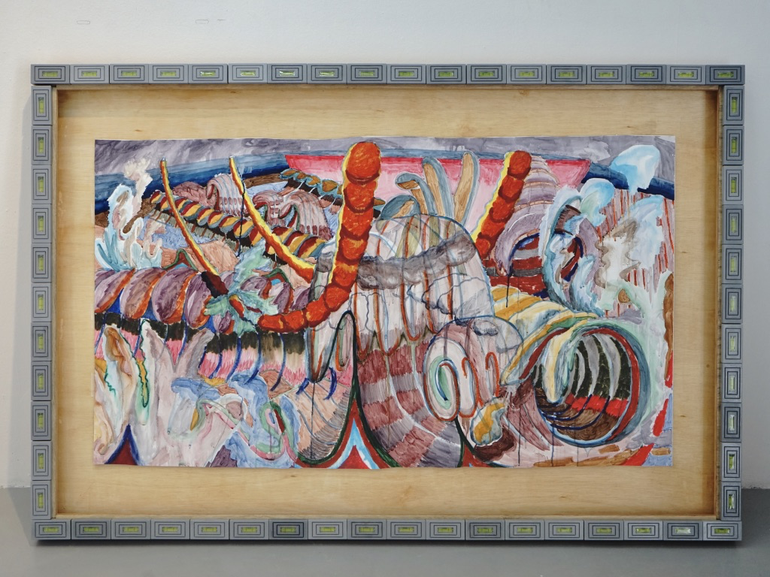 | Mike HJ Chang  Seas’s Guts  2020  Watercolour  on paper, Artist’s Custom-made Frame with Plastic and Levellers  170 x 100 cm
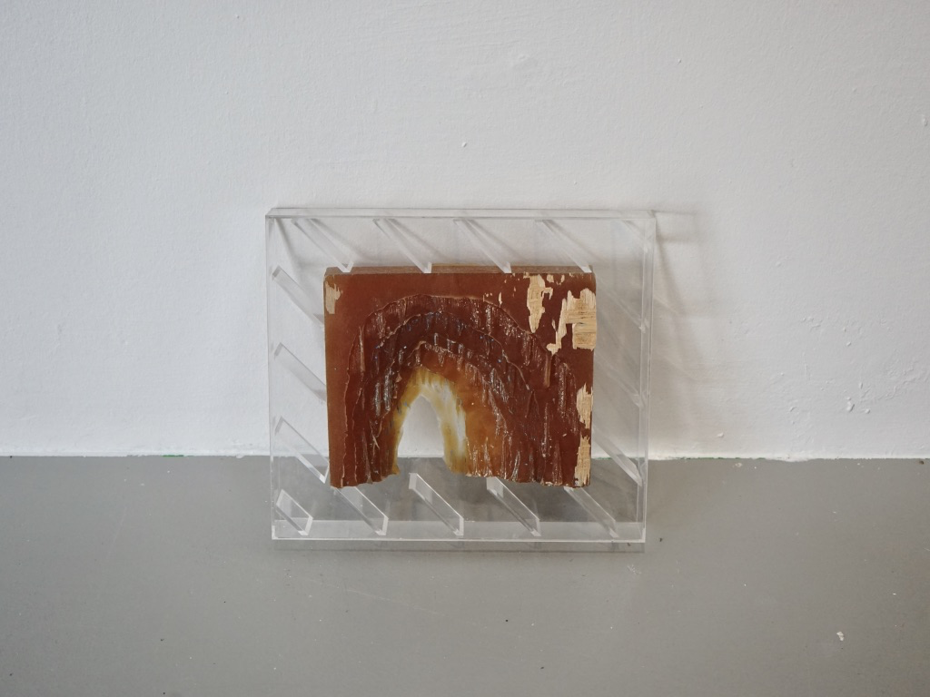 | Mike HJ Chang  Plato’s Cave (a Mould)  2017  Rubber mould in acrylic casing  40 x 30cm
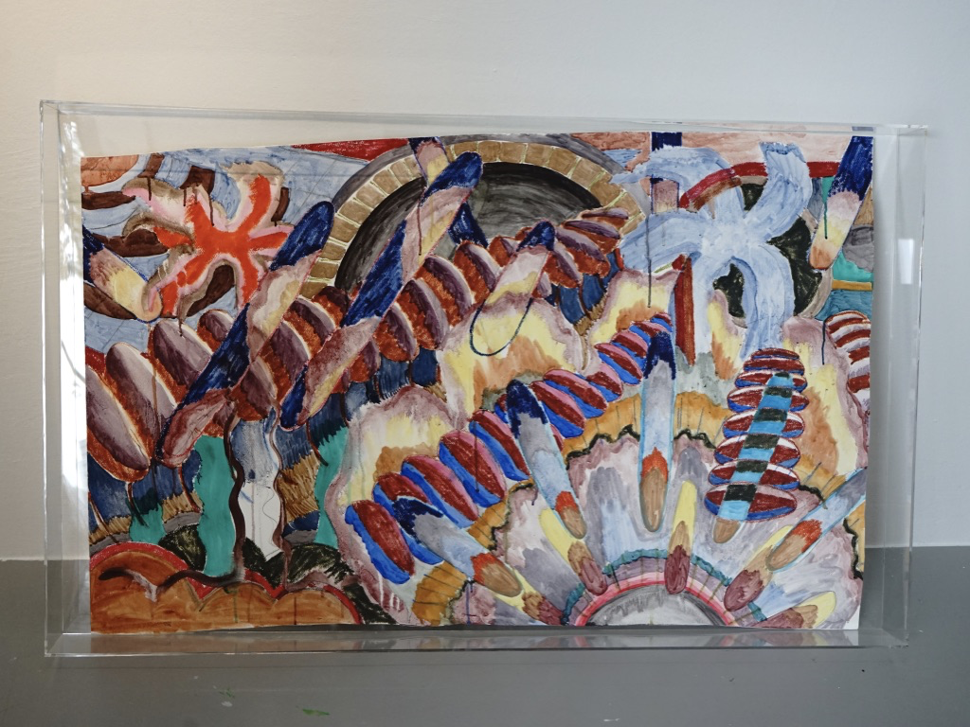 | Mike HJ Chang  Atropa Belladonna  2020  Watercolour on Paper  130 x 80 cm
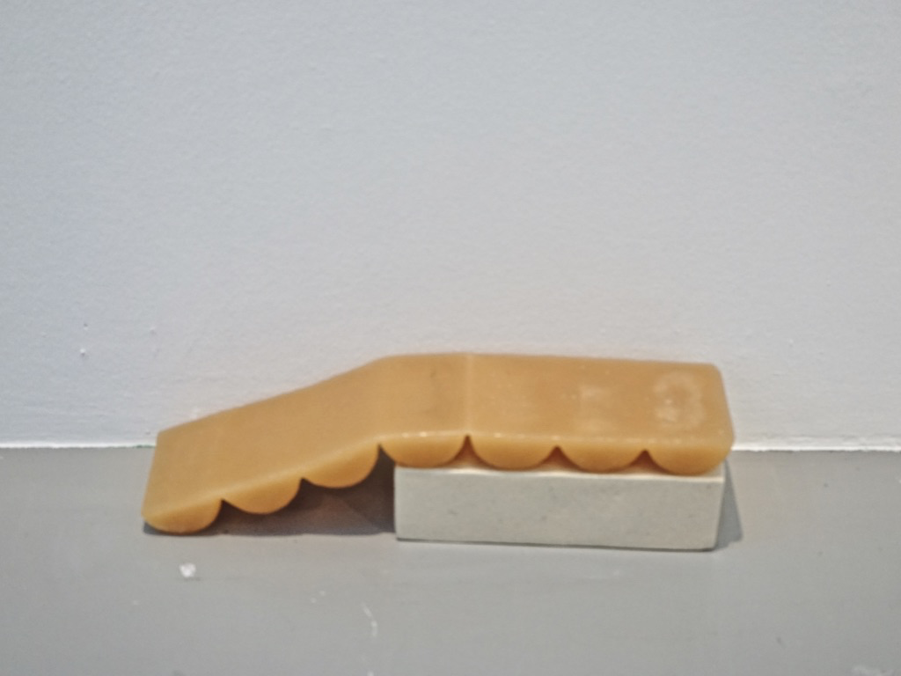 | Mike HJ Chang  Delayed Swell  2020  Ceramic shelf, Silicon rubber slab  40 x 30 cm
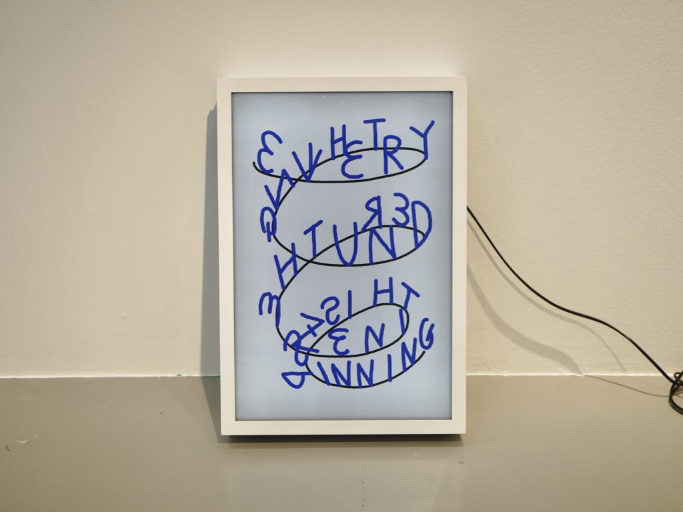 | Mike HJ Chang  Everything Beneath the Zenith is Spinning  2020  Metal lightbox, LED light, digital print  64 x 44 cm
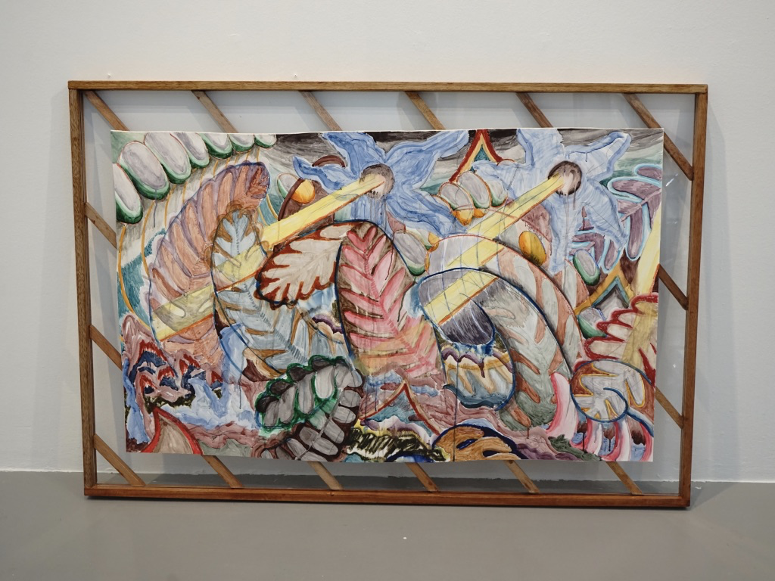 | Mike HJ Chang  Twin Eyes  2020  Watercolour on paper, Artist's custom archival hinging on acrylic and wooden frame  140 x 90 cm
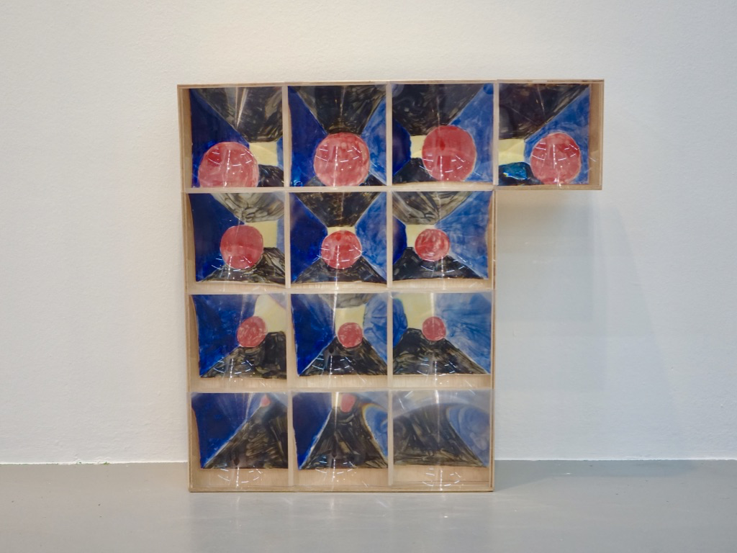 | Mike HJ Chang  Storyboard of a Fruit Soon to be Eaten by an Interdimensional Snake  2020  MDF, magnifying glass  150 x 92 cm
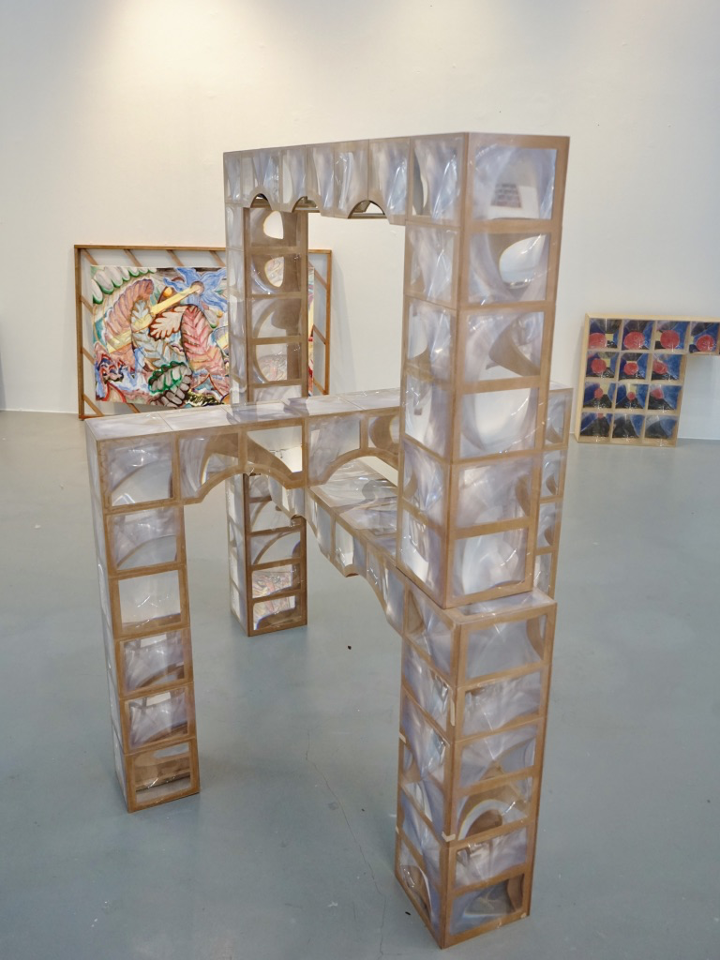 | Mike HJ Chang  Bridges and Canals  2020  Wood,  ceramic tiles, magnifying glass,  3D printed models  Dimensions Variable
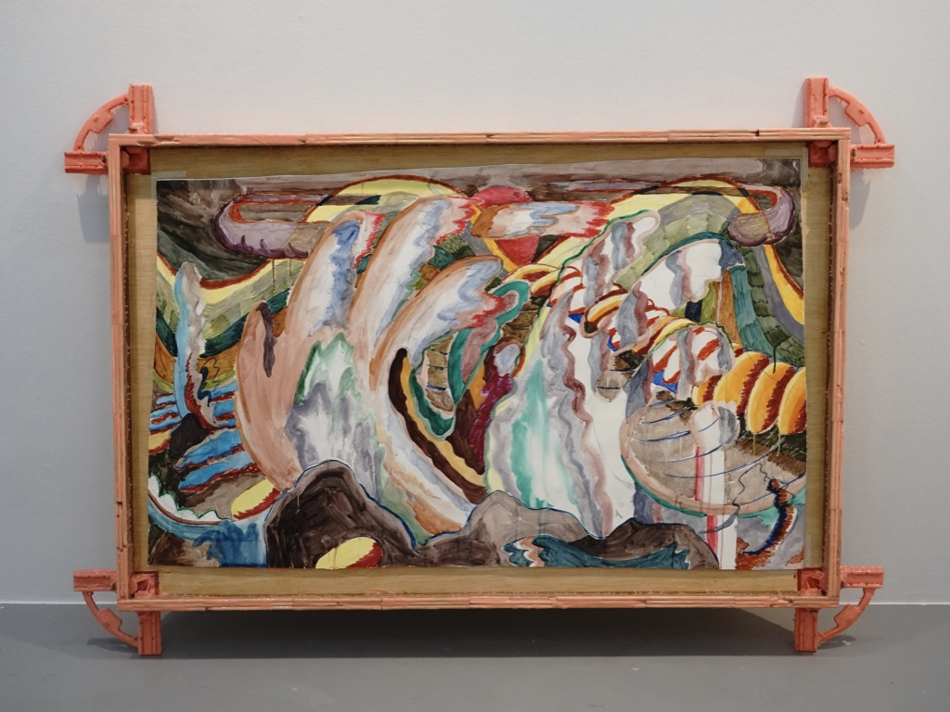 | Mike HJ Chang  The Pendulum  2020  Watercolour  on paper, Artist’s Custom-made Frame with Pencils, Corner Clamps, and Silicon  135 x 85cm
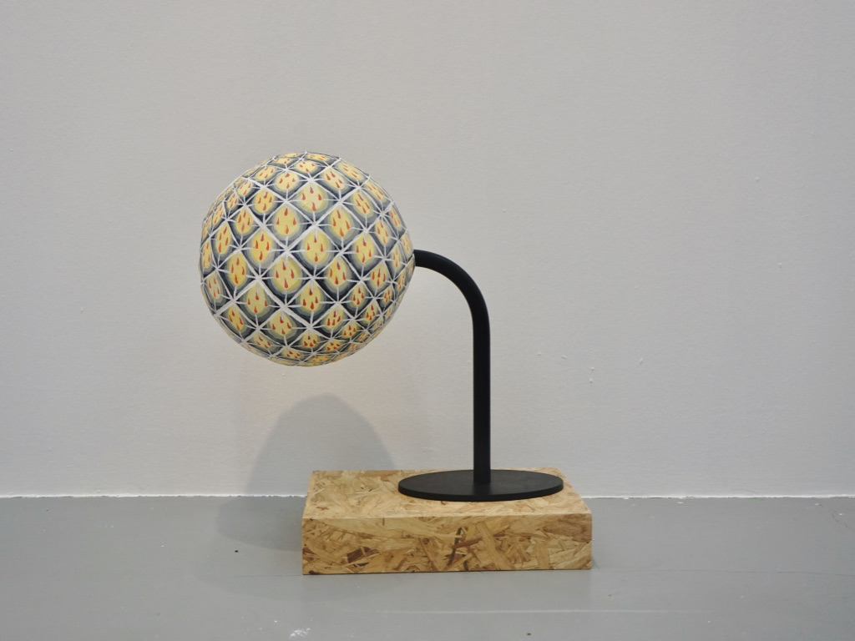 | Mike HJ Chang  Fire Always Point Upward  2020  Paper sculpture, metal stand  50 x 50 cm

